# PE11 – Defining Classes

1. Define the following terms.

inheritance:

parent/base class:

child/derived class:

1. What is wrong with the following code?

public sealed class MyClass

{

// class members

}

public class myDerivedClass : MyClass

{

// class members

}

1. How would you define a non-creatable class?
2. Why are non-creatable classes still useful? How do we make use of their capabilities? Give an example of a non-creatable class that we have used.
3. Write code in a class library project (.NET .DLL) called Vehicles that implements the Vehicle family of objects as outlined below (_424DoubleBogey as the class identifier). There are nine objects and two interfaces (IPassengerCarrier and IHeavyLoadCarrier) that require implementation. The virtual method should be an empty function:

public virtual void LoadPassenger() { }

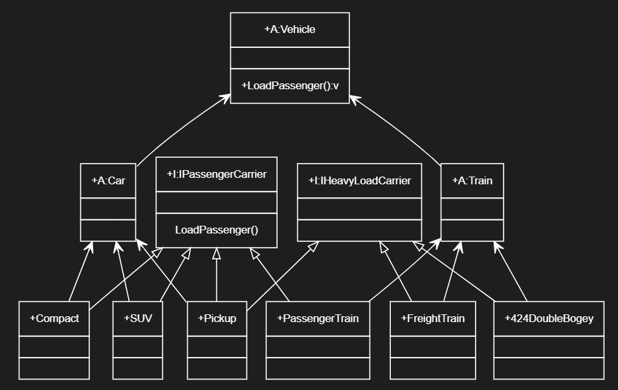

GitHub URL:

1. Create a console application project, Traffic, which references Vehicles.dll (created in Q5 above). Include a function called AddPassenger() that accepts any object with the IPassengerCarrier interface. Within the AddPassenger() function, call the LoadPassenger() method using a reference to the interface. Also add a line to call the ToString() method inherited from System.Object  (ie. if vehicleObject is passed to the function, call Console.WriteLine(vehicleObject.ToString()). Also try passing an object that did not inherit the IPassengerCarrier interface and see what happens.

GitHub URL:

## Submission

Upload this completed document and GutHub URL's for #5 and #6 to the corresponding MyCourses dropbox.